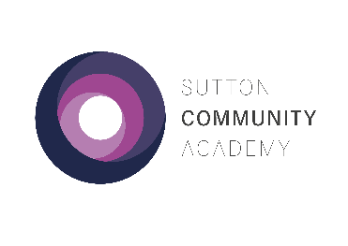
Year 11 Mock Exams – Autumn 2021

Week 1

 | Monday 15th November | Tuesday 16th November | Wednesday 17th November | Thursday 18th November | Friday 19th November
1  09:00– 10:15 | English Language Part 1 [1hr] |  | Biology Part 2 [45 min] |  | Maths Paper 2 Part 1 [1hr]
2  10:15-11:30 | Option Block Z Part 1:  History [1hr]  Computer Science [1hr]  iMedia [1hr15] | Maths Paper 1 Part 1 [1hr]
 | BREAK 1
3  12:00-13:15 |  | Dance & Drama  [1hr] IT1  Option Block Y French Listening:  Foundation [35 min]  Higher [45 min] | Maths Paper 1 Part 2 [30 min] |  | English Language Part 2  [45 min]
 | BREAK 2
4  13:45-15:00 | Biology Part 1 [1hr]  Trilogy Biology [1hr15]  Y10 Statistics [1hr30]  *13:30 start in Exam Room | Option Block Z Part 2:  History [45 min]  Computer Science [30 min] Childcare [1hr30] *13:30 start in Exam Room |  |  | Option Block W French Listening:  Foundation [35 min]  Higher [45 min]

Year 11 Mock Exams – Autumn 2021

Week 2
 | Monday 22nd November | Tuesday 23rd November | Wednesday 24th November | Thursday 25th November | Friday 26th November
1  09:00– 10:15 | English Literature Part 1 [1hr] |  | Chemistry Part 2 [45 min] | Physics Part 1 [1hr]  Trilogy Physics [1hr15] | Maths Paper 3 Part 2  [30 min]
2  10:15-11:30 |  | Maths Paper 2 Part 2 [30 min] |  | Option Block X Part 2:  Geography [30 min]  History [45 min]
 | BREAK 1
3  12:00-13:15 |  |  | Maths Paper 3 Part 1 [1hr] |  | English Literature Part 2  [45 min]
 | BREAK 2
4  13:45-15:00 | Chemistry Part 1 [1hr]  Trilogy Chemistry [1hr15] |  | Option Block X Part 1:  Engineering [1hr] *in Exam Room  Sport Science [1hr] *in Exam Room  Geography [1hr]  History [1hr] |  | Option Block W Part 1:  History [1hr]  French Reading F [45 min]  French Reading H [1hr]

Year 11 Mock Exams – Autumn 2021

Week 3
 | Monday 29th November | Tuesday 30th November | Wednesday 1st December |  | Thursday 2nd December |  | Friday 3rd December
1  09:00– 10:15 | Dance & Drama Practicals [2hr]  Dance in Dance Studio  Drama in Theatre  Health & Social [2hr] *in Exam Room | Option Block W Part 2:  History [30 min]  French Writing F [45 min]  French Writing H [1hr15] | Art 11Y  [5hr]  AD1 | French Speaking Tests | Photography  [5hr]  D5 | French Speaking Tests | Catering Practical  Group 1 [2hr]  Catering room  Catering Online  Group 2 [2hr]  D5 | Art 11W  [5hr]  AD1 | French  Speaking  Tests
2
10:15-11:30
 | BREAK 1 |  |  |  |  |  | BREAK 1
3  12:00-13:15 | Option Block Y Part 1:  French Reading F [45 min]  French Reading H [1hr]  Media Studies [1hr] Construction [1hr15] *in Exam Room | Option Block Y Part 2:  French Writing F [45 min]  French Writing H [1hr15]  Media Studies [30 min] |  |  |  |  | Catering Practical  Group 2 [2hr]  Catering room  Catering Online  Group1 [2hr]  D5
 | BREAK 2
4  13:45-15:00 | Physics Part 2 [45 min]

Please follow the guidance below:

- Arrive at school on time and go to your tutor to register as usual.
- All exams will take place in your normal classroom, unless otherwise stated on the timetable.
- Make your way to the exam and wait outside the room. You will be escorted into the room by a member of staff.
- Check the seating plan if in the Exam Room.
- Exam conditions start as soon as you enter the room.
- Wear full school uniform for all exams.
- Bring your own equipment to each exam in a clear plastic case.
- Bring a clear bottle of water with the label removed. Food is not allowed.
- Switch off your mobile phone and leave it in your bag.
- Remove your wrist watch and leave it in your bag.
- Teacher and/or Invigilators will give you instructions once you are seated. Raise your hand if you have any queries.
- Go to your normal lessons when you don’t have exams.

Good luck!

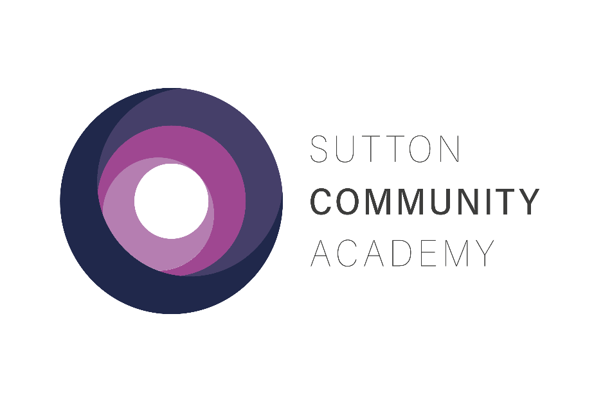
YEAR 11 MOCK EXAMS
AUTUMN 2021

