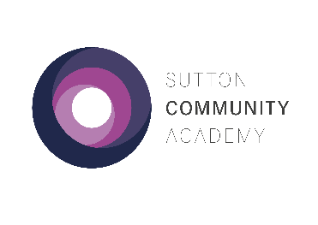
Year 13 Mock Exams – Autumn 2021

Week 1

 | Monday 15th November | Tuesday 16th November | Wednesday 17th November | Thursday 18th November | Friday 19th November
1  09:00– 10:15 | History [2hr30]  Sociology [2hr] | Biology Paper 1 [2hr]  Design and Technology [2hr30]  Law [2hr] |  |  | English Literature Paper 1 [2hr30]  Forensics [2hr]
2
10:15-11:30
 | BREAK 1
3
12:00-13:15
 | BREAK 2
4
13:45-15:00

Week 2
 | Monday 22nd November | Tuesday 23rd November | Wednesday 24th November | Thursday 25th November | Friday 26th November
1  09:00– 10:15 | Business [2hr]  Chemistry Paper 1 [2hr15] | English Literature Paper 2 [3hr]  Y12 Sport [1hr30] | Biology Paper 2 [0hr45] | Psychology [2hr]  Geography [2hr30] | Chemistry Paper 2 [0hr45]
2
10:15-11:30
 | BREAK 1
3
12:00-13:15
 | BREAK 2
4
13:45-15:00
Year 13 Mock Exams – Autumn 2021

Week 3
 | Monday 29th November | Tuesday 30th November | Wednesday 1st December | Thursday 2nd December | Friday 3rd December
1  09:00– 10:15 | Art [5hr]  AD2 | Photography [5hr]  D5
2
10:15-11:30
 |  |  | BREAK 1
3
12:00-13:15
 |  |  | BREAK 2
4
13:45-15:00

Please follow the guidance below:

- Arrive at school on time and go to your tutor to register as usual.
- All exams will take place in the Sports Hall, except practical exams which will take place in the rooms indicated on the timetable.
- Make your way to the exam and wait outside the room. You will be escorted into the room by a member of staff.
- Check the seating plan.
- Exam conditions start as soon as you enter the room.
- Bring your own equipment to each exam in a clear plastic case.
- Bring a clear bottle of water with the label removed. Food is not allowed.
- Switch off your mobile phone and leave it in your bag.
- Remove your wrist watch and leave it in your bag.
- Invigilators will give you instructions once you are seated. Raise your hand if you have any queries.
- Go to your normal lessons when you don’t have exams.

Good luck!

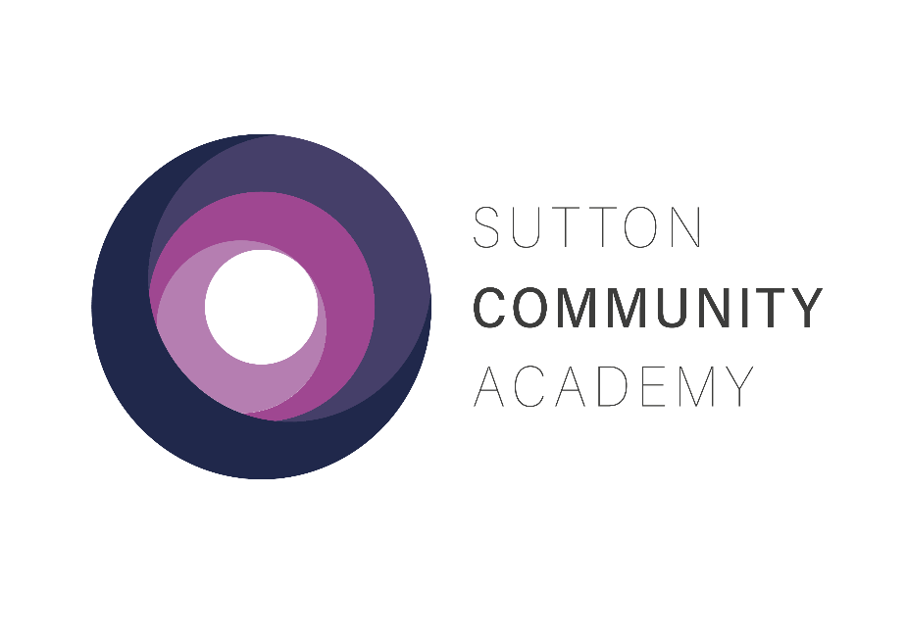
YEAR 13 MOCK EXAMS
AUTUMN 2021

