Student Exam Handbook
2021/22

Centre 28146

Contents
Introduction 3
Purpose of this handbook 3
Malpractice 3
Personal data 3
Copyright 4
Coursework assessments/non-examination assessments 4
Written timetabled exams 4
Contingency day - Summer 2022 4
On-screen tests 4
What to do if you identify you have two or more exam papers timetabled at the same time (a timetable clash) 5
Where you will take your exams 5
What time your exams will start and finish 5
Supervision during your exams 5
Exam room conditions 5
Where you will sit in the exam room 6
How your identity is confirmed in the exam room 6
What equipment you need to bring to your exams 6
Using calculators 7
What you should not bring into the exam room 7
Food and drink in exam rooms 8
What you should wear for your exams 8
Where your personal belongings will be stored during your exam 8
What to do if you arrive late for your exam 8
What to do if you are unwell on the day of your exam 8
What happens if you have an unauthorised absence from your exam 8
What happens in the event of an emergency in the exam room 8
Candidates with access arrangements/reasonable adjustments 9
Results Days 2022 9
Post-results services 9
Certificates 9
Internal appeals procedures 9
Complaints and appeals procedure 9
Appendix 1 10
JCQ Information for candidates – coursework assessments 2021-2022 10
JCQ Information for candidates – non-examination assessments 2021-2022 12
JCQ Information for candidates – on-screen tests 2021-2022 14
JCQ Information for candidates – written exams 2021-2022 16
JCQ Information for candidates – Privacy Notice 17
JCQ Information for candidates – social media 20
JCQ Unauthorised items poster 21
JCQ Warning to candidates poster 22

Introduction
Sutton Community Academy is committed to ensuring that candidates are fully briefed on the exam and assessment process in place in the centre and are made aware of the required JCQ/awarding body instructions and information for candidates. This handbook should be read in conjunction with the information supplied on the Academy website, exams section: www.suttonacademy.attrust.org.uk

Purpose of this handbook
The purpose of this handbook is
- To support candidate briefings/assemblies
- To inform candidates about malpractice in examinations/assessments
- To inform candidates about the use of their personal data and copyright
- To ensure candidates are provided with all relevant information about their exams and assessments in advance of any exams/assessments being taken
- To ensure copies of relevant JCQ information for candidates documents and exam room posters are provided in advance of any exams/assessments being taken
- To answer questions candidates may have etc.
- To inform candidates of/signpost candidates (and where relevant parents/carers) to any exams-related policies/procedures that they need to be made aware of

Malpractice
- To maintain the integrity of qualifications, strict regulations are in place.
- Malpractice means any act or practice which is in breach of the regulations.
- Any alleged, suspected or actual incidents of malpractice will be investigated and reported to the relevant awarding body/bodies.
- JCQ provides information regarding what constitutes malpractice:
  - Introduction of unauthorised material into the examination room
  - Breaches of examination conditions
  - Exchanging, obtaining, receiving, or passing on information which could be examination related (or the attempt to)
  - Offences relating to the content of candidates’ work
  - Undermining the integrity of examinations/assessments

You must read the following JCQ documents – please see the school website or appendix 1 at the back of this handbook:
- JCQ Information to candidates – social media
- JCQ Information for candidates - written examinations
- JCQ Information for candidates – on-screen tests
- JCQ Information for candidates – non-examination assessments
- JCQ Information for candidates – coursework assessments

Personal data
- The awarding bodies collect information about exam candidates.
- To understand what information is collected and how it is used, you must read the JCQ Information for candidates – Privacy Notice. Please see the school website or appendix 1 at the back of this handbook.

Copyright
The copyright of any work created by a candidate that is submitted to an awarding body for assessment (referred to as Assessment Materials) belongs to the candidate. By submitting this work, a candidate is granting the awarding body a non-exclusive, royalty-free licence to use their assessment materials (referred to as Assessment Licence). If a candidate wishes to terminate the awarding body’s rights for anything other than assessing his/her work, the awarding body must be notified by the centre and it is at the discretion of the awarding body whether or not to terminate such rights.

Coursework assessments/non-examination assessments
• You will be advised by Subject Teachers when these assessments will take place.
• For formal assessments, you will be informed in writing of when the assessment will take place.
• Please be aware of and ensure you meet any deadlines set by your Subject Teacher.
• Depending on the type of assessment, it will be marked by your teacher and then moderated by the awarding body, or it will be sent to the awarding body for marking.
• Your Subject Teacher will advise you of your mark before the work is sent to the awarding body. If you wish to appeal against your mark, please speak to your Subject Teacher in the first instance.
• Please read the procedure regarding appeals in the exams section of the school website.
You must refer to the relevant JCQ Information for Candidates documents on coursework assessments and non-examination assessments – see appendix 1 at the back of this handbook or the school website.

Written timetabled exams
- A few weeks before your summer exams, you will be issued with a statement of entry.
- Please check the information on the statement of entry carefully, and if there is anything wrong, advise your Subject Teacher and the Exams Officer.
- Your parent/carer will need to sign the statement of entry, and you must then return it to school.
- After the signed statement of entry is returned to school, a final exam timetable will be issued. This will include your candidate exam number.
- Please learn your candidate number. This will stay the same for all your exams and you must write this on the front of every exam paper.
- JCQ exam room posters – warning to candidates, unauthorised materials - and the seating plan for the exam will be displayed outside each room. Please look at these as you enter the room to remind yourself of the regulations and to check your seat number.
- Whole-school exam timetables are published on the school website, and copies are also put on the exams noticeboard in the dining room.

Contingency day - Summer 2022
JCQ have designated Wednesday 29th June 2022 as a ‘contingency day’ for examinations, in the event of national or local disruption to exams. Candidates will be expected to make themselves available up to this date. Please be aware of this date when planning holidays.

On-screen tests
- You will be advised, in writing, of your exam location and time.
- Please check the information given, and if there is anything wrong, advise your Subject Teacher and the Exams Officer.
- JCQ exam room posters – warning to candidates, unauthorised materials - and the seating plan for the exam will be displayed outside each room. Please look at these as you enter the room to remind yourself of the regulations and to check your seat number.
- Exam timetables are also published on the school website
You must refer to the JCQ Information for Candidates – on-screen tests. Please see the school website or appendix 1 at the back of this handbook.

What to do if you identify you have two or more exam papers timetabled at the same time (a timetable clash)
- There may be a time when your exam timetable shows two exams at exactly the same time. Don’t panic, this happens quite a lot.
- The Exams Officer will arrange for you to take one exam first, followed by the second, with a short break in between. You must not leave the room unsupervised during the short break, and exam conditions will remain in place.
- Depending on the length of your clash, sometimes you might need to sit one of the exams earlier or later than the published time. You will need to be supervised at all times if this happens. The Exams Officer will make the necessary arrangements and communicate these to you.
- Sometimes you might have a clash that requires overnight supervision. The Exams Officer will make the necessary arrangements and communicate these to you.

Where you will take your exams
The whole-school exam timetable, available on the school website and the exams noticeboard in the dining room, will give details of where your exams will be held. This may be the Sports Hall or the Exam Room. On-screen exams may be held in one of the IT rooms, and practical exams may be held in specialist classrooms, such as Art and Catering rooms.

What time your exams will start and finish
- Your exams will normally start at 09:30 for a morning session and 13:30 for an afternoon session. Please make sure you arrive at least 10 minutes before the start of the exam.
- Please make sure you go to the toilet before the exam. You will not be allowed to go to the toilet for the first 30 minutes or the last 30 minutes, unless you have a medical/toilet pass. You will be escorted to the toilet by an invigilator.
- You will not be allowed to leave the exam before the end.
- If the exam finishes before 10:00 in the morning or 14:30 in the afternoon, you will have to stay in the exam room, under supervision, until that time. This is to make sure we maintain the security of the exam and comply with JCQ regulations.

Supervision during your exams
- Exams are supervised by a team of invigilators who are employed by school at exam times. They are fully trained to make sure the exams are carried out in accordance with the JCQ regulations.
- It is the job of the invigilator to watch students as they do their exam. They will not approach you unless you raise your hand for assistance, or they suspect malpractice.
- The invigilator cannot give you any help with your exam.
- Each invigilator will have a supply of stationery, so if you need anything please raise your hand and they will come to you.
- The Exams Officer and the invigilators are responsible for making sure your exams go as smoothly as possible and that the process is fair for everyone.

Exam room conditions
• You must wait outside the room to be escorted into the exam by a senior member of staff or an invigilator. Use this time to check the seating plan, to remove your watch and put it in your bag, and to switch off your phone and put it in your bag. Check that you have nothing in your pockets.
• You will be under formal exam conditions from the moment you enter the exam room until you are given permission to leave by the invigilator. This means that you must not talk to, attempt to communicate with or disturb other candidates once you have entered the room.
• You must leave your bag in the designated area and then find your seat quickly and quietly. There will be numbers and letters on the walls to help you, and a place card on each desk. Invigilators will help you if you can’t find your seat. Do not ask another candidate.
• You must listen to and follow the instructions of the invigilator at all times.
• The exam paper will have been placed on your desk before you enter the room. Do not attempt to look inside it or read anything. This is malpractice.
• Don’t write anything on the front of the paper until you are instructed to do so by the invigilator.
• At the front of the room you will see a whiteboard displaying the following information, which you will need when you are asked to fill in the front of your exam paper:
- Centre number: 28146
- Subject title
- Paper number
- Actual start and finish times
- Date
• When you are asked to fill in the details on the front of your exam paper, please use your legal name and not your preferred name. If a signature is required, please enter this as it is very important.
• When the exam starts, the invigilator will display the actual start and finish times of the exam.
• If you need to leave the room because you are feeling unwell, please raise your hand and an invigilator will assist you. You are not allowed to leave the room on your own.
• Please make sure that you put your name, candidate exam number and question on any additional sheets of paper you may use.
• You must not write on the desk – this will be regarded as vandalism and you will have to pay for any damage.
• You must not deface your exam paper as the awarding body may refuse to mark it.

Where you will sit in the exam room
- Your seat number will be displayed on the seating plan outside the exam rooms.
- It is very important that you make sure you sit at the correct desk so that you sit the correct exam paper, so check the place card on the desk before you sit down.
- If you are unsure of where to sit, please raise your hand and an invigilator will assist you.

How your identity is confirmed in the exam room
A senior member of centre staff (approved by the Head of Centre, who has not taught the subject being examined) will be present at the start of the exam to assist with the identification of students.

What equipment you need to bring to your exams
You will need:
• A black ball-point pen (must be black) and spares
• Pencil
• Ruler
• Eraser
• Highlighter (you can highlight the question paper but not your answers)
• Clear pencil case
• Scientific calculator (unless the exam does not allow a calculator) without a lid/cover
• Maths exams may also require a protractor, set square and compass. Your Maths teacher will give you more information regarding the equipment needed.
• Some exams may need coloured pencils. Your subject teacher will advise you.
• You are not allowed to borrow equipment from another student during the exam

Using calculators
For exams where a calculator is allowed, you must be aware of the JCQ instructions:
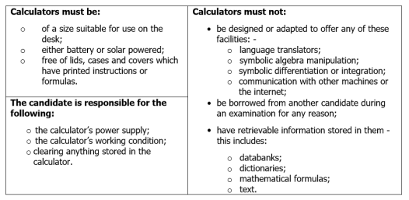

What you should not bring into the exam room
It is very important that you do not enter the room with any unauthorised items in your possession. These items include:
• Mobile phones
• MP3/4 players
• Wrist watches of any type
• iPods
• Any other similar electronic devices
• Earphones
• Revision notes and study guides
• Your own blank paper
• Calculators, unless allowed for the exam
• Calculator lid/cover
• Dictionaries, unless allowed for the exam
• Miscellaneous items such as make-up, lip salve, bus passes, money and keys, student reports and exam timetables
• Food items
• Correction fluid or tape
Please make sure you check all your pockets.

Food and drink in exam rooms
- You are allowed to take a clear bottle of water into the exam. The label must be removed before you enter the room.
- Other drinks, such as juice or fizzy pop, are not permitted
- Food is not permitted.

What you should wear for your exams
You must wear full school uniform for all exams. If you are in the Sixth Form, you must adhere to the dress code for all exams.

Where your personal belongings will be stored during your exam
You must leave your coats and bags, and any other possessions, in the designated areas in the exam rooms.

What to do if you arrive late for your exam
You must arrive at least 10 minutes before the start of your exam. If you are late for any reason, please report to reception and tell the member of staff that you have an exam. You will be collected from reception and escorted to the room. You will be given the full time allowed for your exam. If you arrive very late for an exam (after 10:00am for a morning exam and after 14:30 for an afternoon exam) you will still sit the exam but there is a chance that the awarding body will not mark your paper.

What to do if you are unwell on the day of your exam
It is really important that you attend school for all exams, whether external or mock, unless you are seriously ill.
• If you are extremely unwell and cannot attend your exam, please ask your parent/carer to contact the Attendance Officer immediately on 01623 980055 ext. 5135. Tell the Attendance Officer that you are missing an exam because you are ill. You may need to provide medical evidence to confirm your illness.
• If you feel unwell during an exam, please put your hand up and an invigilator will assist you.
• If you feel unwell before the exam starts, please tell a member of staff.
• If you are disadvantaged because of illness, it may be possible for the Exams Officer to apply for special consideration. Evidence may be requested to support this.

What happens if you have an unauthorised absence from your exam
Your exams are extremely important and it vital that you attend all external and mock exams. If you do not turn up for an exam you will not receive a mark/grade, and your parents/carers will be invoiced for the wasted exam entry fee.
Please advise your LoLA of any issues you may have around exam time that could affect your attendance.

What happens in the event of an emergency in the exam room
In the event of an emergency evacuation alarm, the invigilator will stop the exam and give instructions to you.
You must:
- Stop writing and close your exam papers.
- Stay seated until the invigilator advises you to leave the room.
- Follow the invigilator to the designated exams assembly points (Construction carpark for exams in the Sports Hall; front slope for exams in the Exam Room).
You must not:
- Communicate with anyone inside or outside the room, other than the Exams Officer and invigilators.
- Collect any personal belongings, unless advised to do so by the invigilators.
- Return to your usual tutor group assembly point – remain with the Invigilator at all times.
If you do not follow these rules, you may not be allowed back into the room to complete your exam.
Once it is safe to re-enter the building, the Invigilator will re-start the exam and you will be given the full time to complete it.

Candidates with access arrangements/reasonable adjustments
If you are entitled to an access arrangement such as a reader and/or a scribe, you will take your exams in a smaller room, such as one of the squash courts. Trained invigilators will be present in the room to give assistance. They, too, have to comply with the JCQ regulations, so there are certain things they are not allowed to do. If you are unsure of how your access arrangement will work, please speak to Mrs Bailey-Wiles, SENCO.

Results Days 2022
Results Days take place in August each year. This year, A Level results will be released on Thursday 18th August 2022, and GCSE results will be released on Thursday 25th August 2022. Further details and timings will be shared with you in the summer term.
On Results Days, senior members of centre staff will be available immediately after the publication of results to offer support, and to advise you should you wish to use the post-results services. Please remember that results are provisional until the awarding bodies issue your certificates.
If you are unable to collect your results in person on results day then:
- Your results can be posted to you on the day. You must bring a stamped addressed envelope into school.
- You can send someone else to collect your results on your behalf. They will need to bring with them written authorisation and photographic ID.

Post-results services
There is a JCQ post-results service available after you have received your results. This is administered by the Exams Officer, with input from senior leaders and Subject Teachers. Your signed consent will be obtained before processing any requests to use the service as your grades may go up, go down or stay the same.
The post-results services available are a clerical check (service 1), a review of marking (service 2), a review of moderation (service 3) and access to scripts.
Full details will be given to you in the summer term, but in the meantime, you can read the Access to Scripts, Reviews of Results and Appeals Procedures on the school website.

Certificates
Your exam certificates are produced by the awarding bodies and are sent to school in the autumn term, following the release of your results in August. You will be sent details of how and when to collect your certificates before Christmas. It is important that you collect your certificates because we can only keep them for 12 months, after which they are destroyed.

Internal appeals procedures
There are appeals procedures in place should you wish to appeal against:
- any internal assessment decisions
- any decisions not to support your request to use post-results services
You can read these procedures on the school website.

Complaints and appeals procedure
Sutton Community Academy has a policy in place regarding Complaints and Appeal procedures in relation to the delivery or administration of a qualification. This is available to read on the school website.

Appendix 1

JCQ Information for candidates – coursework assessments 2021-2022

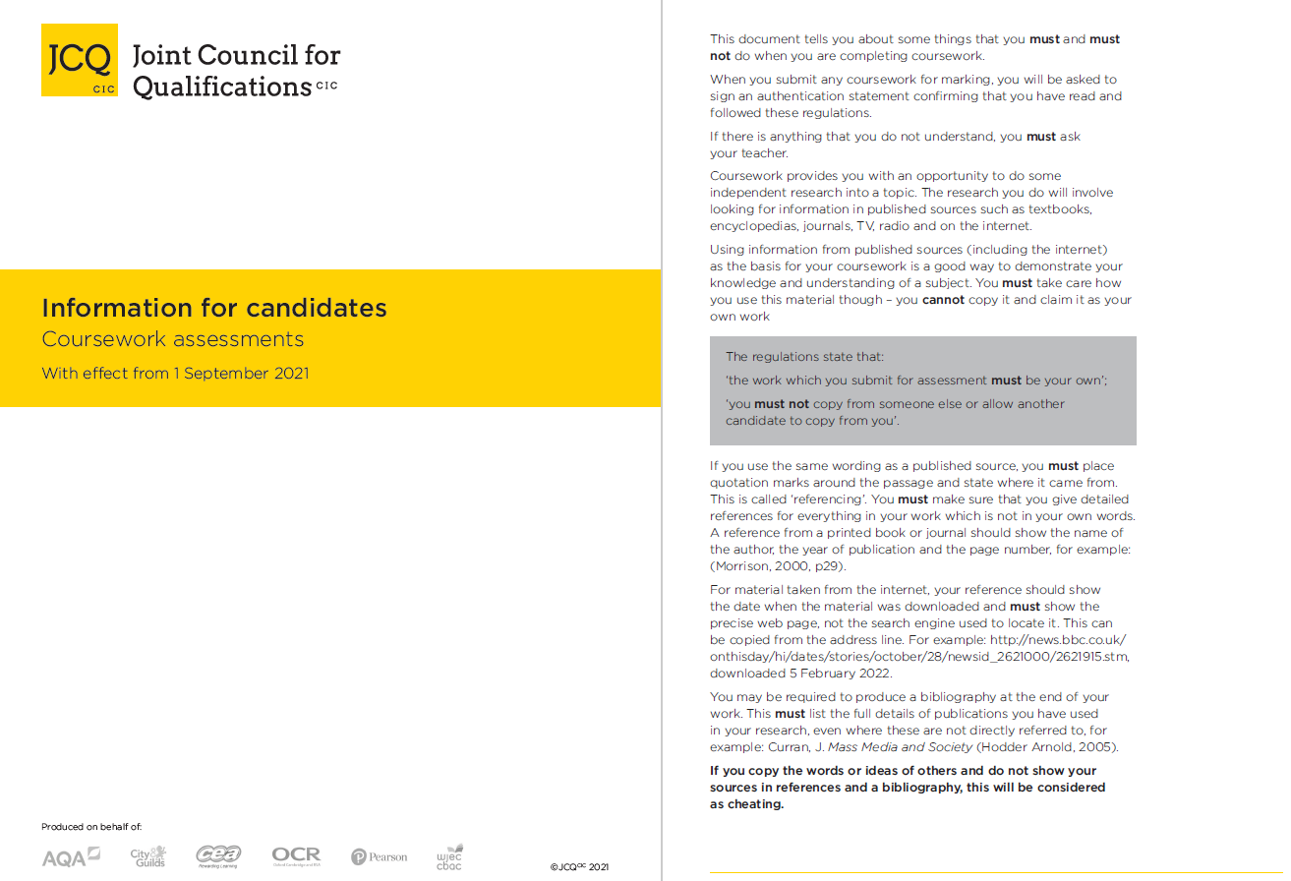

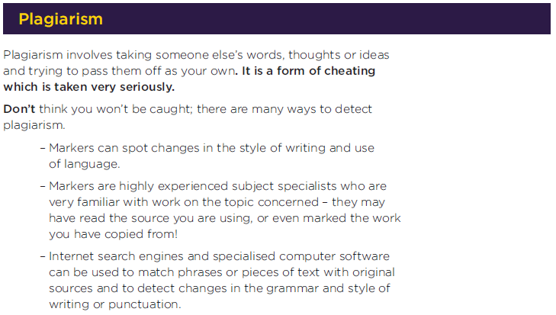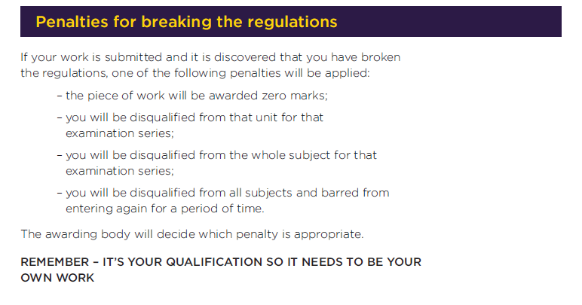

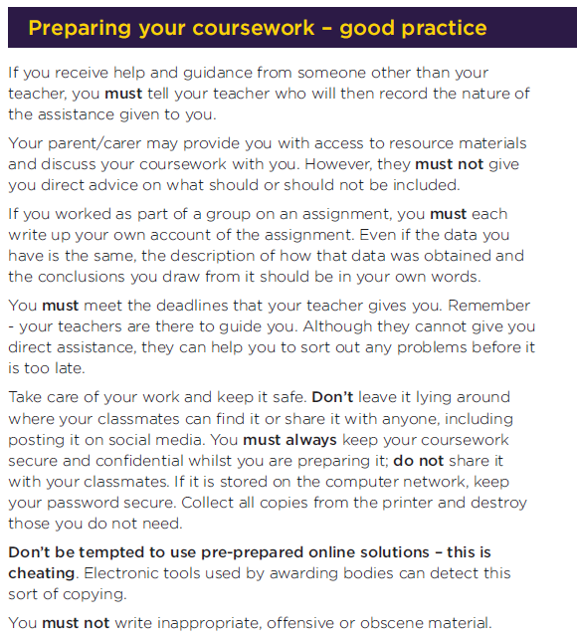

JCQ Information for candidates – non-examination assessments 2021-2022

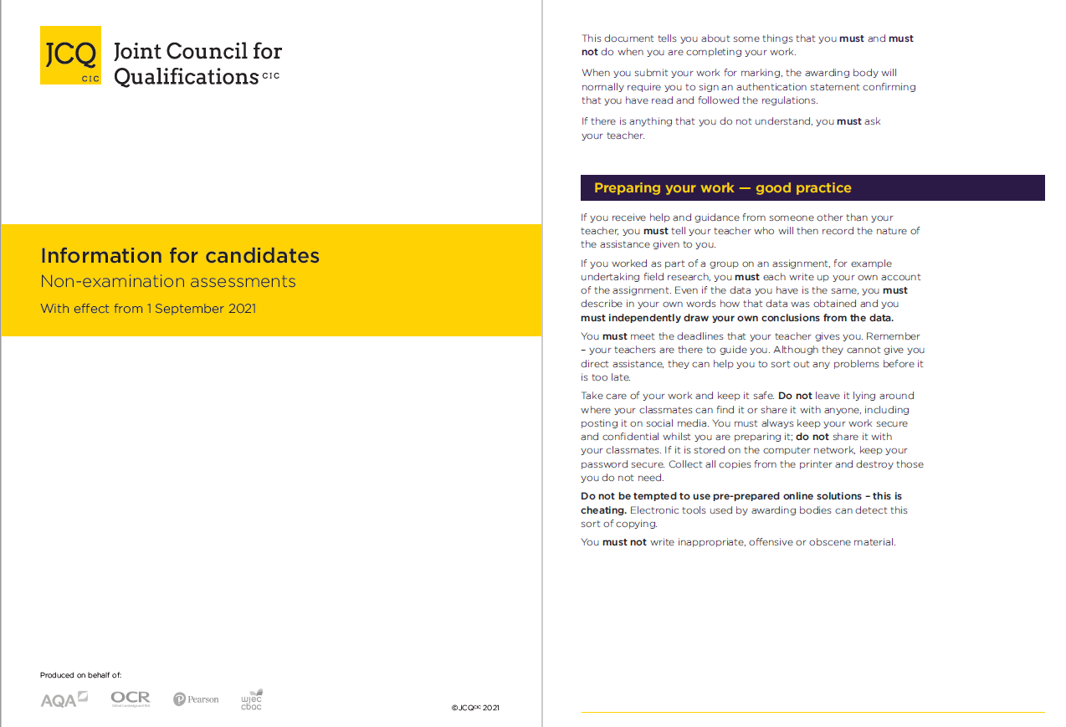

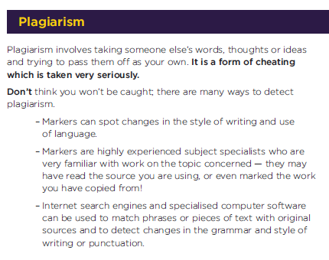
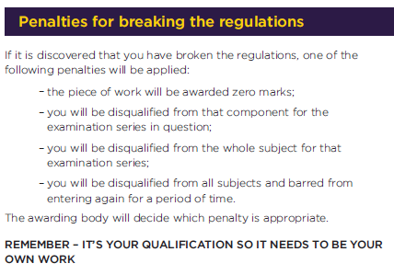

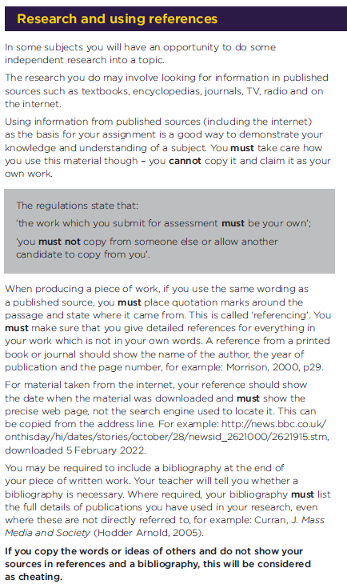

JCQ Information for candidates – on-screen tests 2021-2022

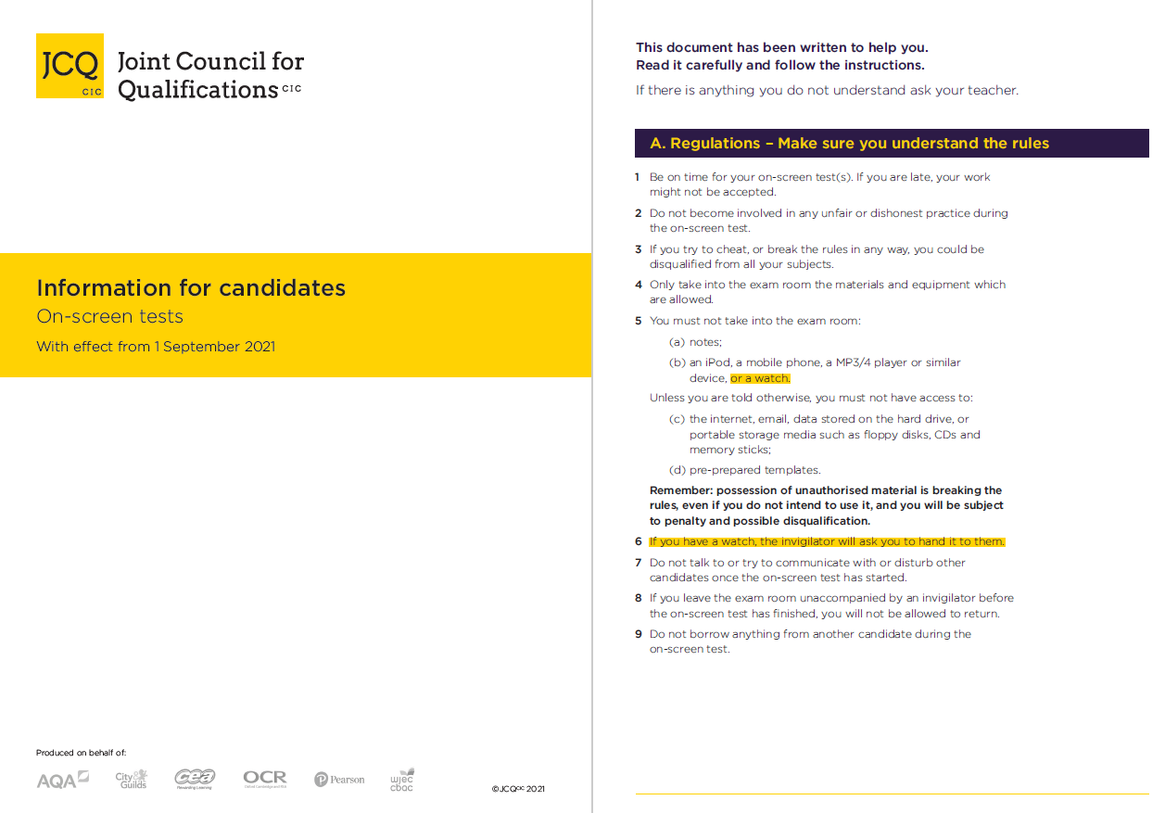
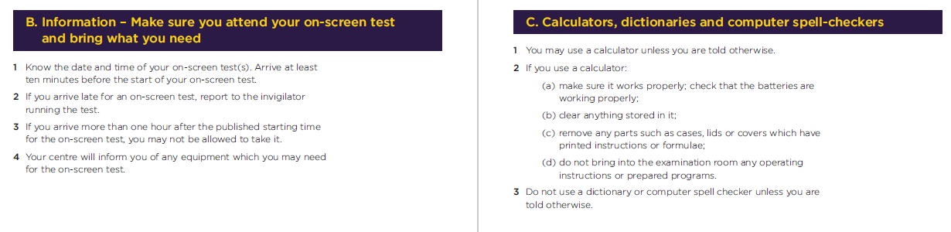
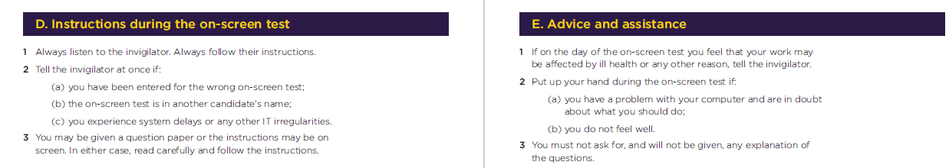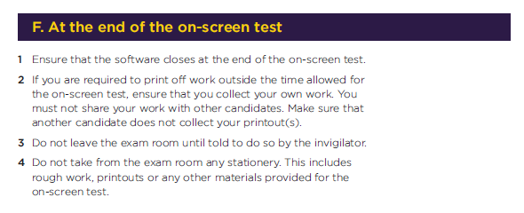

JCQ Information for candidates – written exams 2021-2022
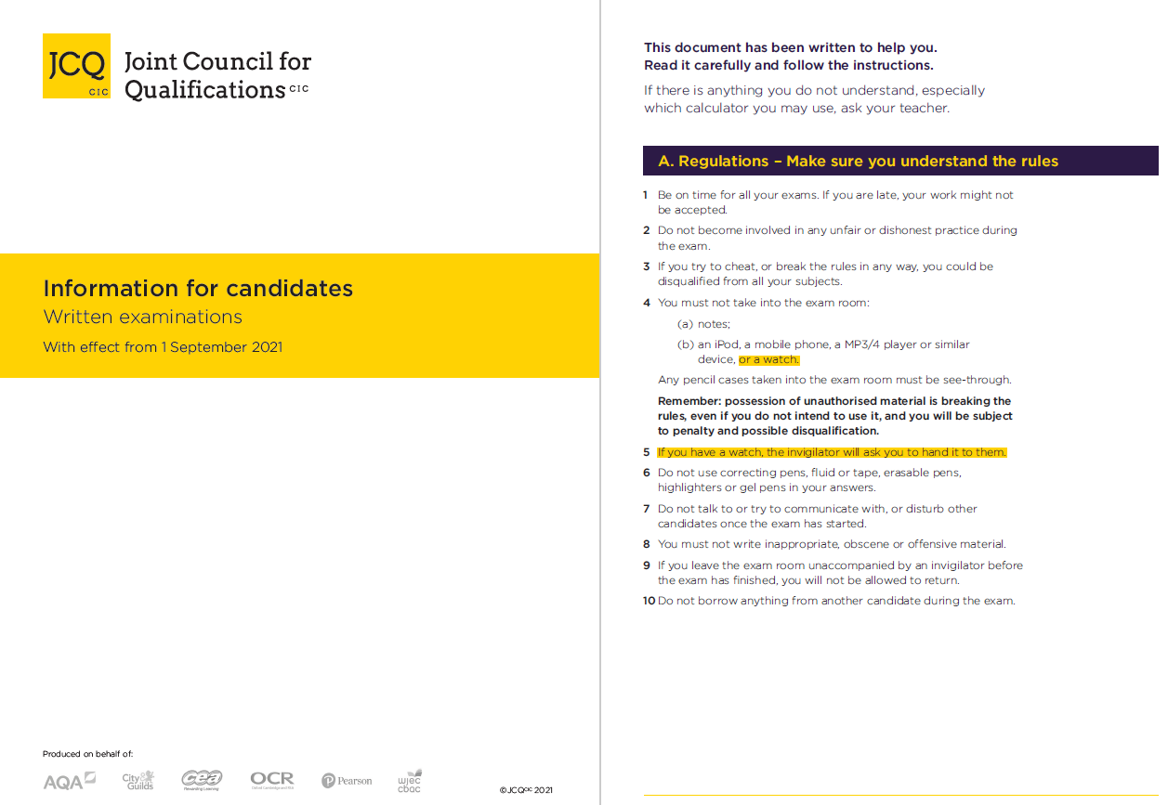
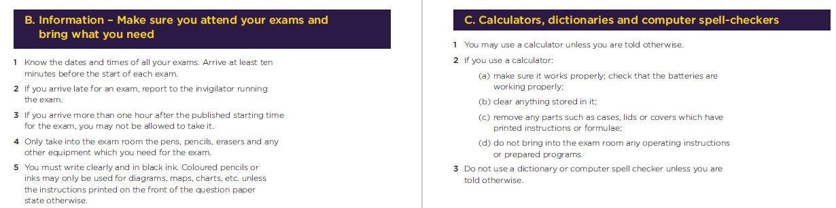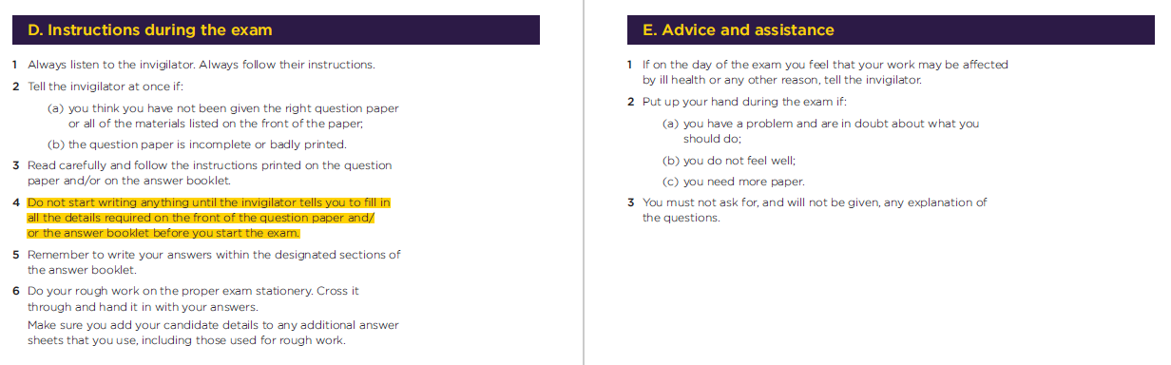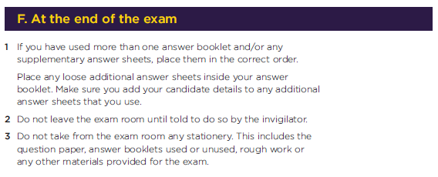

JCQ Information for candidates – Privacy Notice

Information for Candidates
Information About You and How We Use It
You have entered general or vocational qualifications such as GCSE, A-level, functional skills qualifications etc with one or more of the awarding bodies listed above. In order to be able to provide examinations and assessments, the awarding body needs to collect and use information about you. This notice provides you with a high level summary of the information the awarding body is required by law to give you about what happens to that information. For more detail see each awarding body’s full Privacy Notice:

AQA https://www.aqa.org.uk/about-us/privacy-notice
CCEA http://ccea.org.uk/legal/privacy_policy
City & Guilds https://www.cityandguilds.com/help/help-for-learners/learner-policy
NCFE https://www.ncfe.org.uk/legal-information
OCR https://www.ocr.org.uk/about/our-policies/website-policies/privacy-policy/
Pearson https://qualifications.pearson.com/en/about-us/qualification-brands/gdpr.html
WJEC https://www.wjec.co.uk/home/privacy-policy/

Who we are and how to contact us
Each awarding body is a separate organisation. Your school or examination centre will be able to confirm to you which awarding body is delivering each qualification you are undertaking and you will receive a statement confirming what qualifications you have been entered for and which awarding body. You will find links to each awarding body’s website and information on how to contact them here: https://www.jcq.org.uk/contact-our-members/

Information about you and from where it is obtained
Each awarding body whose qualifications you enter will need to use a variety of information about you. This includes obvious identification details such as your name, address, date of birth and your school or examination centre. It also includes information about your gender, race and health, where appropriate. This information is provided by you or your parents/guardians and/or by your school or examination centre.
Each awarding body will create certain information about you such as a candidate number, examination results and certificates.
You will find further information about this in the awarding bodies’ full Privacy Notice (see links above) or by contacting the awarding body (see above).

What happens to the information about you
The awarding bodies use the information about you to deliver the examinations and assessments which you have entered. This includes making a variety of arrangements for you to sit the examinations or assessments, marking, providing you and your school or centre with results and certificates. The awarding bodies also use some of the information about you for equality monitoring and other statistical analysis.
The awarding bodies may share information about your results with official bodies such as the Department for Education and the examinations regulators (e.g. Ofqual in England) and also relevant local authorities and the Universities and Colleges Admissions Service (UCAS). An awarding body may also use information about you to investigate cheating and other examination malpractice and will share information about malpractice with other awarding bodies.
The awarding bodies take the security of the information about you that they hold seriously.
You will find further, technical information about what the awarding bodies do with information about you, why and the legal basis in the awarding bodies’ full Privacy Notice, which can be accessed here (see links on page one) or by contacting the awarding body (see above).

Your rights
The law gives you a number of rights in relation to the information about you that the awarding bodies hold. Those rights are:
- Access – you are entitled to ask each awarding body about the information it holds about you.
- Rectification – you are entitled to ask each awarding body to correct any errors in the information that it holds about you.
- Erasure – in certain circumstances you are entitled to ask each awarding body to erase the information about you that it holds.
- Object to or restrict processing – in certain circumstances you are entitled to ask each awarding body to stop using information about you in certain ways.
- Complain – you are entitled to complain to the Information Commissioner (the body regulating the use of personal information) about what each awarding body does with information about you.
You will find further information about your rights in relation to information about you in the awarding bodies’ full Privacy Notice, which can be accessed here (see links on page one) or by contacting the awarding body (see above).

How long the information about you is held
Each awarding body retains information about you only for as long as it is needed. Some of the information is needed only during the period in which you are undertaking the examination or assessment and is securely destroyed a short while afterwards. Other information about you, such as your name, gender, address, qualification and subjects entered and the results, are held indefinitely and for at least 40 years.
Each awarding body has its own retention policy that sets out what information it retains, how it is retained and for how long. You can find out more about retention policies by contacting each awarding body (see above).

How to find out more about the information about you that the awarding bodies use
To find out more about the information about you that the awarding bodies collect and use, including what happens to that information and why, you can review the awarding bodies’ full Privacy Notice, which can be accessed here (see links on page one) or contact the awarding body. You will find links to each awarding body’s website and information on how to contact them here: https://www.jcq.org.uk/contact-our-members/.

Please note
It is important to note that this notice concerns only how the awarding bodies use information about you (called your “personal data”). Complaints about how an awarding body handles your personal data can be made to the Information Commissioner (www.ico.org.uk). Information about the examinations and assessments themselves, including the rules about assessments, can be found on the JCQ Exams Office pages (www.jcq.org.uk/exams-office). The awarding bodies are regulated by Ofqual (https://www.gov.uk/government/organisations/ofqual) in England; Qualifications Wales
(www.qualificationswales.org) in Wales, and the Council for the Curriculum, Examinations and Assessment (http://ccea.org.uk/regulation) in Northern Ireland.

JCQ Information for candidates – social media

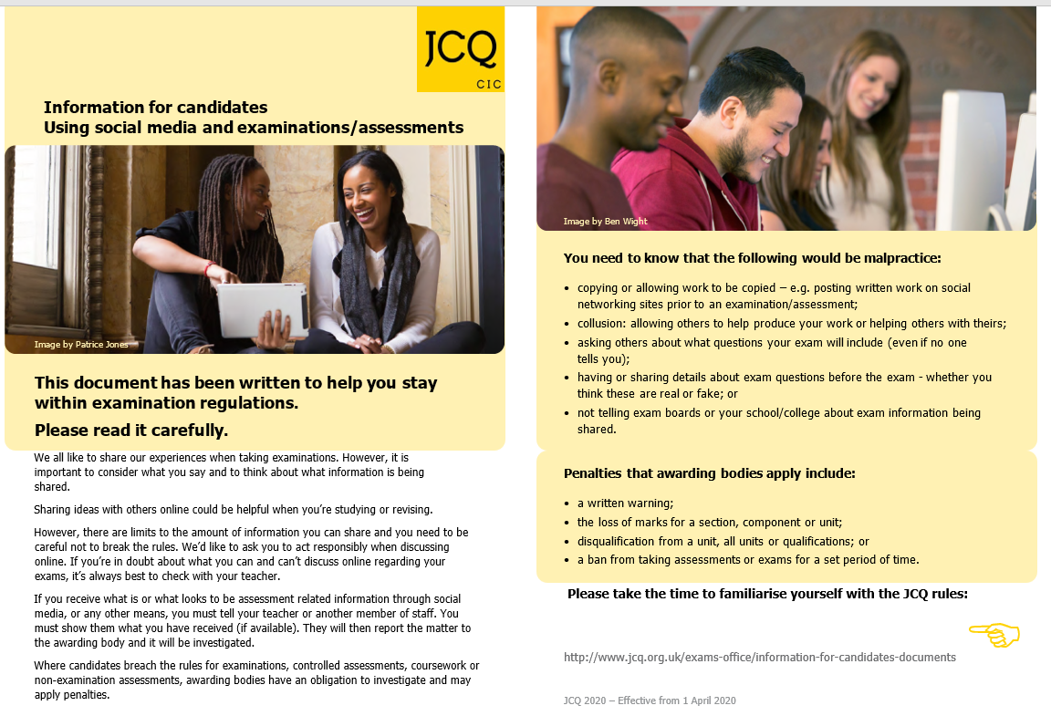

JCQ Unauthorised items poster
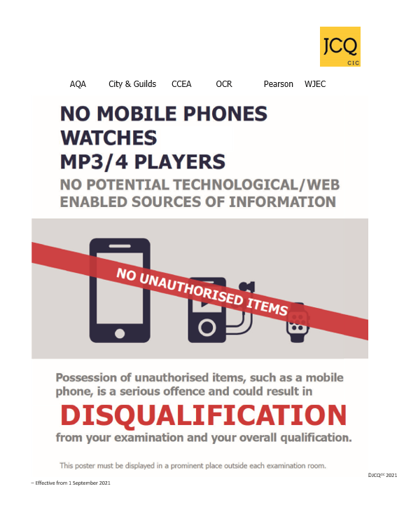

JCQ Warning to candidates poster
