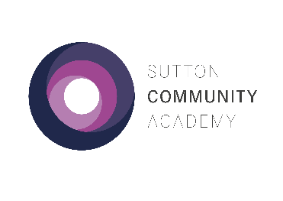**Year 13 Mock Exams – Spring 2023**

**Week 1**

|  |  |  |  |  |  |
| --- | --- | --- | --- | --- | --- |
|  | Monday 20th February | Tuesday 21st February | Wednesday 22nd February | Thursday 23rd February | Friday 24th February |
| 1  09:00– 10:15 | English Literature Paper 1  2hr 30min  Physics Paper 1 2hr | Sociology Paper 1 2hr | Geography 3hr 30min  Chemistry Paper 1 2hr  Psychology Paper 1 2hr | Photography  5 hr (D5) | Photography  5 hr [D5] |
| 2  10:15-11:30 |
| BREAK 1 |  | | |
| 3  12:00-13:15 |  |  |  |
| BREAK 2 |  | | |
| 4  **13:30**-15:00 | Maths Paper 1 2hr | Biology Paper 1 2hr |  |

**Week 2**

|  |  |  |  |  |  |
| --- | --- | --- | --- | --- | --- |
|  | Monday 27th February | Tuesday 28th February | Wednesday 1st March | Thursday 2nd March | Friday 3rd March |
| 1  09:00– 10:15 | History Paper 1 1hr  Psychology Paper 2 2hr  Chemistry Paper 2 2hr | Maths Paper 2 2hr  Y12 Maths Paper 1 1hr 30min | Sociology Paper 2 2hr  Physics Paper 2 2hr | Media Studies Paper 1  2hr 15min [Exam1] | Biology Paper 2 2hr |
| 2  10:15-11:30 |
| BREAK 1 |  | | | |  |
| 3  12:00-13:15 |  |  |  |  |  |
| BREAK 2 |  | | | |  |
| 4  **13:30**-15:00 |  |  |  |  | Psychology Paper 3 2hr  [Exam1] |

**Year 13 Mock Exams – Spring 2023**

**Week 3**

|  |  |  |  |  |  |
| --- | --- | --- | --- | --- | --- |
|  | Monday 6th March | Tuesday 7th March | Wednesday 8th March | Thursday 9th March | Friday 10th March |
| 1  09:00– 10:15 | History Paper 2  1hr 30min  Psychology Paper 3 2hr  Chemistry Paper 3 2hr | English Literature Paper 2 3hr  Physics Paper 3 2hr | Media Studies Paper 2  2hr 30min [Exam1] | Art  5hr [AD2] | Art  5 hr (AD2) |
| 2  10:15-11:30 |
| BREAK 1 |  | | |
| 3  12:00-13:15 |  |  |  |
| BREAK 2 |  | | |
| 4  **13:30**-15:00 | Maths Paper 3 2hr  Y12 Maths Paper 2  1hr 30min | Sociology Paper 3 2hr  Biology Paper 3 2hr |  |

Please follow the guidance below:

* Arrive at school on time and go to your tutor to register as usual.
* All exams will take place in the Sports Hall except Art exams, which will take place in the rooms indicated on the timetable.
* Make your way to the exam and wait outside the room. You will be escorted into the room by a member of staff.
* Check the seating plan.
* Exam conditions start as soon as you enter the room.
* Bring your own equipment to each exam in a clear plastic case.
* Bring a clear bottle of water with the label removed. Food is not allowed except for Art exams.
* Switch off your mobile phone and leave it in your bag.
* Remove your wrist watch and leave it in your bag.
* Invigilators will give you instructions once you are seated. Raise your hand if you have any queries.
* Go to your normal lessons when you don’t have exams.

**Good luck!**

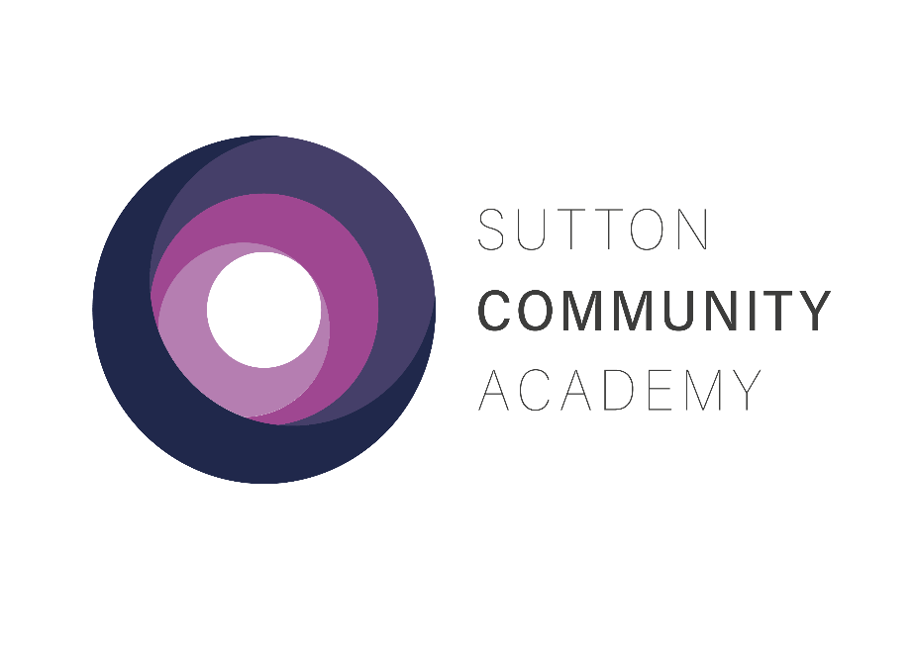

YEAR 13 MOCK EXAMS

SPRING 2023